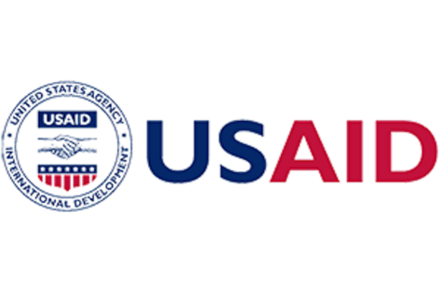
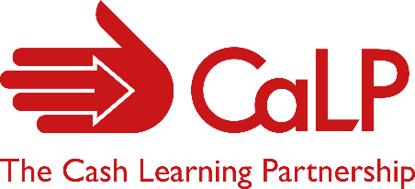
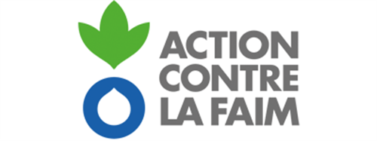

Consultant - Programme Management – CaLP in West and Central Africa
Terms of Reference

Presentation of the CaLP network
CaLP’s purpose is to maximise the potential that humanitarian CVA can bring to people in contexts of crisis, as one component of broader financial assistance. CaLP envisions a future where people are enabled to overcome crises with dignity, by exercising choice and their right to self-determination in order to achieve long term well-being. Our role as a collective is to optimise the quality and scale of humanitarian CVA by generating alignment in the approaches and actions of those within and across our network.
Context
In West and Central Africa, CaLP’s office is hosted by Action Contre la Faim regional office (WARO) and funded thanks to the Bureau for Humanitarian Assistance (BHA). CaLP’s team is working with its +90 member organizations to develop skills and knowledge on CVA and improve humanitarian practice and coordination. CaLP’s regional geographic coverage stretches from the Coastal countries, the Sahel Belt up to the Chad Lake Basin and Francophone countries in Central Africa, and thus CaLP’s team works mainly in French with external partners. Working closely with the Cash Working Groups in the region, CaLP delivers its activities in line with the current programme, running until end of September 2021.
As CaLP is transitioning to new ways of working in line with its new strategy recently released and some changes in the regional team. We are looking for a highly competent professional, dedicated to improving the quality of humanitarian assistance, to support the delivery of CaLP’s regional programme.
Objectives of the consultancy
The main objective of this consultancy is to support the smooth and timely delivery of all activities planned under the regional BHA programme, until the end of September 2021. More specific tasks are defined below, in a non-comprehensive list:
Lead the delivery of the following tasks
- Finalization of the consultancy for the review of the MEB tip sheet
- Supervise and coordinate the translation of resources in French, working closely with the capacity building team on training materials, and the communications team on the Programme Quality Toolbox, ensuring that timelines are respected
- Ensuring a part of the proofreading in French of resources that have been translated from English
- Coordinate with colleagues to share proofreading workload, making decisions on prioritization
- Prepare and work with CWGs to organize a CWG leads workshop
- Follow-up with partners on the piloting of CaLP’s decision making tool for nutrition actors
- Work with the Global Cluster, regional partner, members and colleagues to organize a learning event on CVA for nutrition outcomes, drawing learning from the piloting of CaLP’s decision-making tool

Proposal development
In agreement with the CaLP’s Director and in collaboration with others:
- Support or lead the development of proposal for renewed funding for the regional office or/and CaLP’s global funding
- Lead donor reporting, working closely with CaLP’s team and hosts, especially on the narrative side, and ensure that financial reports are submitted on time

Project management
- Work with CaLP’s team and members to ensure the highest quality of all deliverables planned under the regional programme
- Work closely with CaLP’s team to coordinate activities planned under the programme
- Monitor delivery of the workplan based and propose adjustments based on the evolution of needs and priorities for partners and CaLP
- Work with CaLP’s Business Support Officer and ACF’s finance team, review financial forecasts and propose adjustments
- Work closely with CaLP regional Business Support Officer to ensure smooth and timely procurement processes in line with workplan and host agencies’ compliance rules
- Regularly report to CaLP’s SMT and supervisor to anticipate any change in the workplan and financial projections. Flag any variances, delays in activities, or expected under/overspent or regional resources.

Other
- Work closely with other colleagues to provide regional insights to CaLP global activities
- Attend agreed team and external meetings regularly and as relevant

The estimated number of working days for this consultancy is 150, ideally running from February to October 2021.
Contract
The selected consultant will be contracted by Action Contre la Faim on behalf of CaLP. Terms of payments will be on a monthly basis upon reception of an invoice.
Applications and requirements
To apply, consultants should submit an updated CV (max 3 pages) clearly referring to similar experience and highlighting relevant skills and expertise, before February 11 midnight (Dakar time) to lmbodj@wa.acfspain.org cc nathalie.klein@calpnetwork.org, with a cover letter (max 1 side) that should explain motivation and how experience makes the applicant appropriate for the role. It should also include the proposed daily rate (max USD400).

The selected consultant will have:
- Strong experience of programme management
- Strong knowledge of cash and voucher assistance
- Field experience in delivering humanitarian assistance
- Excellent writing and oral skills in English and French

